Welcome to the official GameSimFall2016 Advanced TortoiseSVN guide.

IF YOU HAVENT COMPLETED “BasicSVNTutorial.docx” YET, GO DO SO NOW.

Fair warning: This is an advanced guide. Some things in here will be useful to some, and not so useful to others. The document will likely be many, many pages long. You have been warned.

This guide will teach you a few things:

1. How to open the SVN Logs.
2. How to download WinMerge.
3. What to do in the event of a conflict.
4. How to revert to a previous version of a file.
5. How to modify your context menu settings.
6. How to move a versioned file.
7. How to rename a versioned file.
8. How to delete a versioned file.

**SECTION 1: HOW TO OPEN THE SVN LOGS**

Navigate your way to the file/folder you wish to find. Right click the item and select “TortoiseSVN”, then select the “Show log” option.

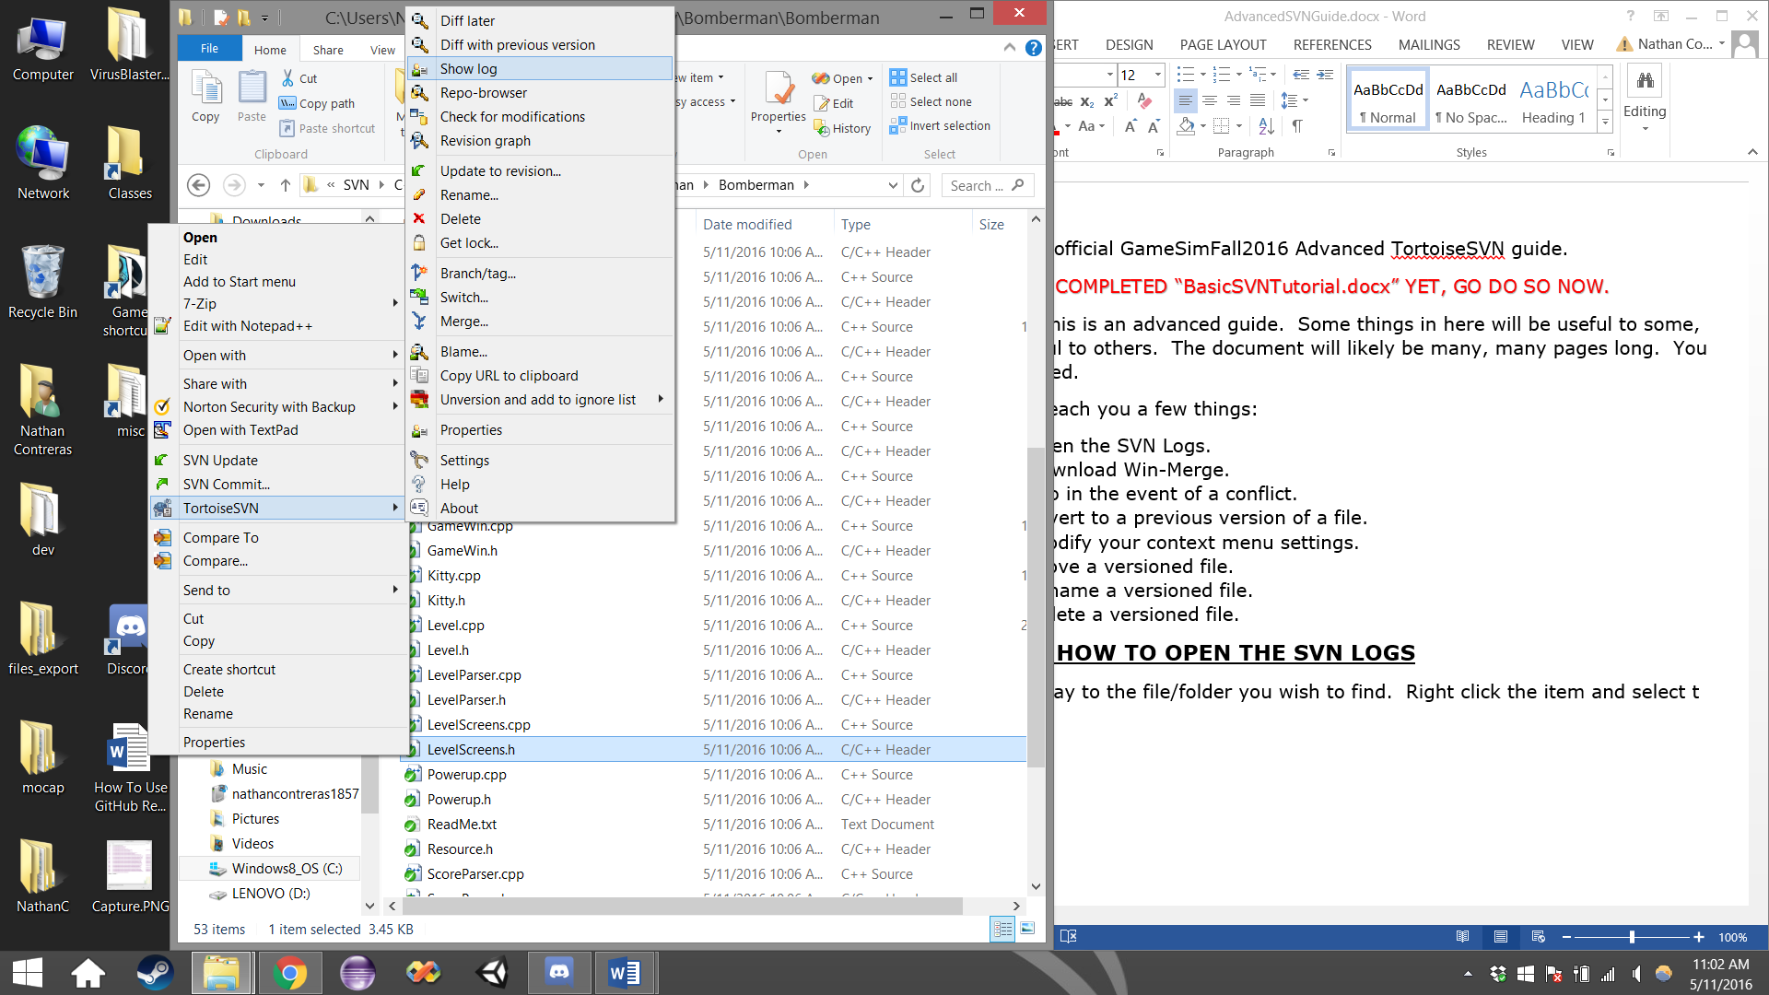

Now you will be presented with the Log screen. From here you will be able to see everyone’s previous commits to a file, this way you can figure out who changed the file you’ve been working on, and figure out who broke your build.

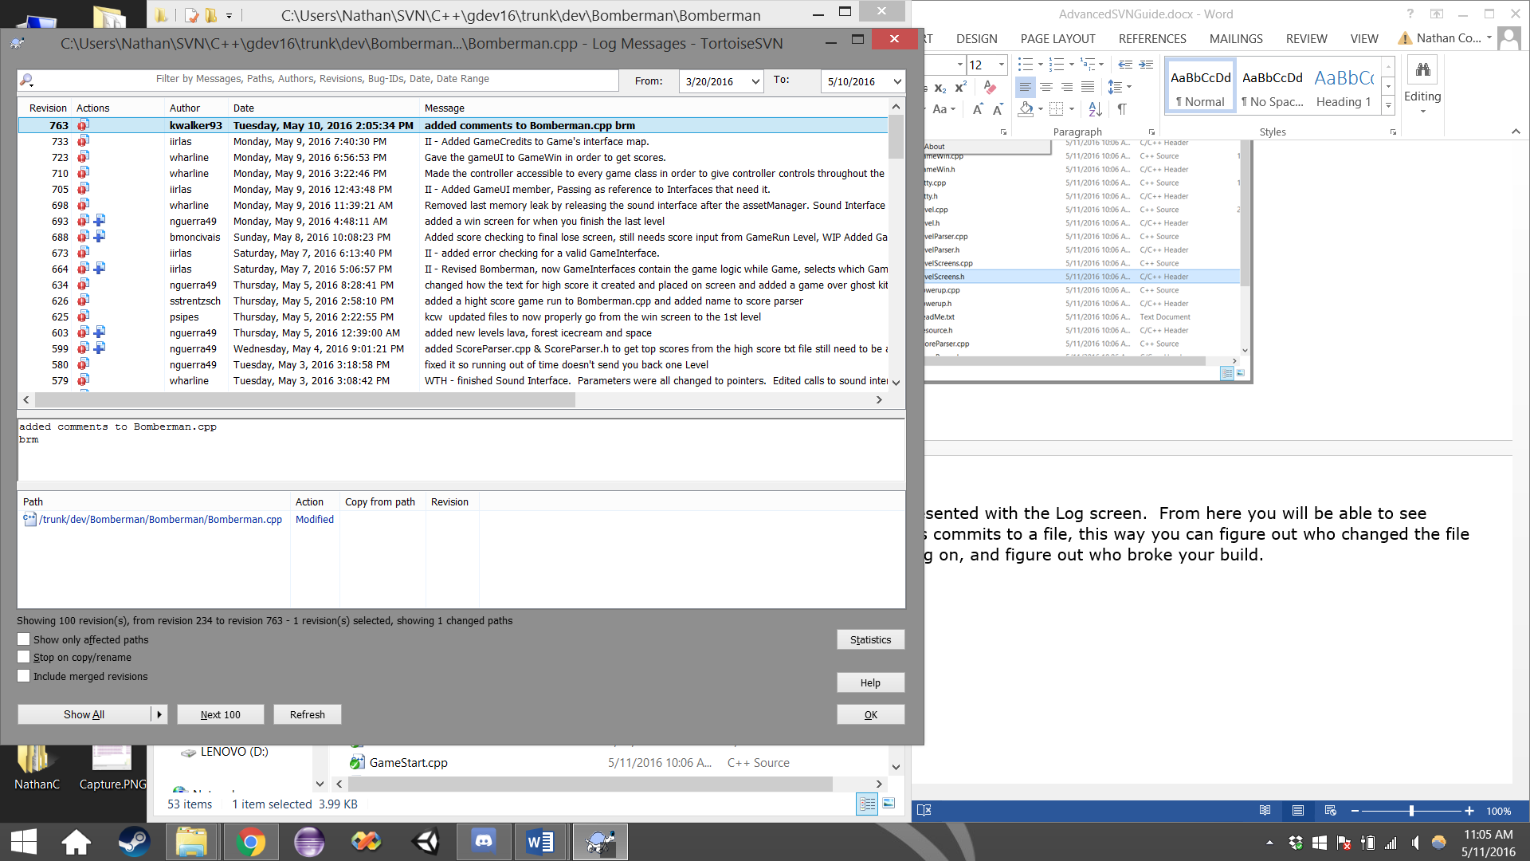

**SECTION 2: HOW TO DOWNLOAD WINMERGE**

WinMerge is an extremely useful tool that can be very handy, but also very destructive, it should be used with caution. It presents a great way to combine conflicted word documents and code.

Load the WinMerge website: <http://winmerge.org/>

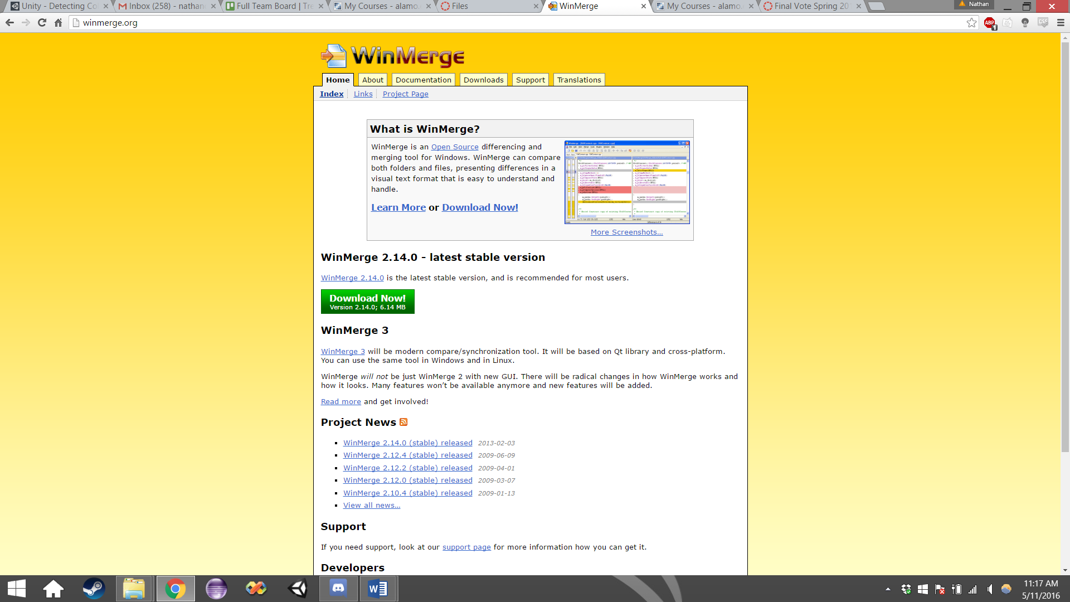

Click the large green download button, simple as that. You will be redirected to the webpage below, your download will occur automatically. Once it is downloaded, run the file.



After running the file, follow the on-screen instructions to setup WinMerge. If you want the basic install, just click the next button. If you are an advanced WinMerge user (which is probably not the case), modify the settings displayed on the install screen as you see fit. A system restart might be necessary. You should now have WinMerge available for your usage. Congratulations!

**SECTION 3: Fixing a conflicted file**

Let’s say you run into one of the worse outcomes in the repository. A conflicted file. A conflicted file occurs multiple ways, but the most common occurrence is described in this scenario below.

* I open up some code, “Bomberman.cpp” version 102 and “Bomberman.h” version 12.
* I make some edits over the course of a couple hours.
* At some point during these couple hours, someone named “userB” was also editing “Bomberman.cpp” and committed their changes before I finished mine.
  + This means the latest working copy has been updated from version 102 to version 103.
  + I am currently working on version 102.
* After all my edits, I try to commit my file.
  + The repository currently holds the latest version, 103, and I’m trying to update version 102. The repository sees that there is an error, that I am not using the latest version. This error is known as a conflict error.
* In order to fix this error, I will need to merge the changes between my file, and the file “userB” has used.
* The following steps should allow you to successfully merge a word document/code change.

>>> TODO: ADD SLIDES ABOUT FIXING A CONFLICTED FILE <<<

**SECTION 4: Reverting to a previous file version**

Let’s say you messed up bad. Like, really bad. Like, you’re buying lunch for everyone bad. Maybe you didn’t mean to mess up this bad, but you did. Let’s say that you pushed some code to the repository that causes the whole game to just straight up display seizure-inducing psychedelic colors, and the only hope left for the project to even succeed is for you to scrap every change you just made… But you don’t actually remember what all you changed. That’s alright, you won’t be burned at the stake yet, but you still owe everyone lunch. Thankfully TortoiseSVN provides a really useful tool to help with this situation.

Open up the logs for the file/folder in question.

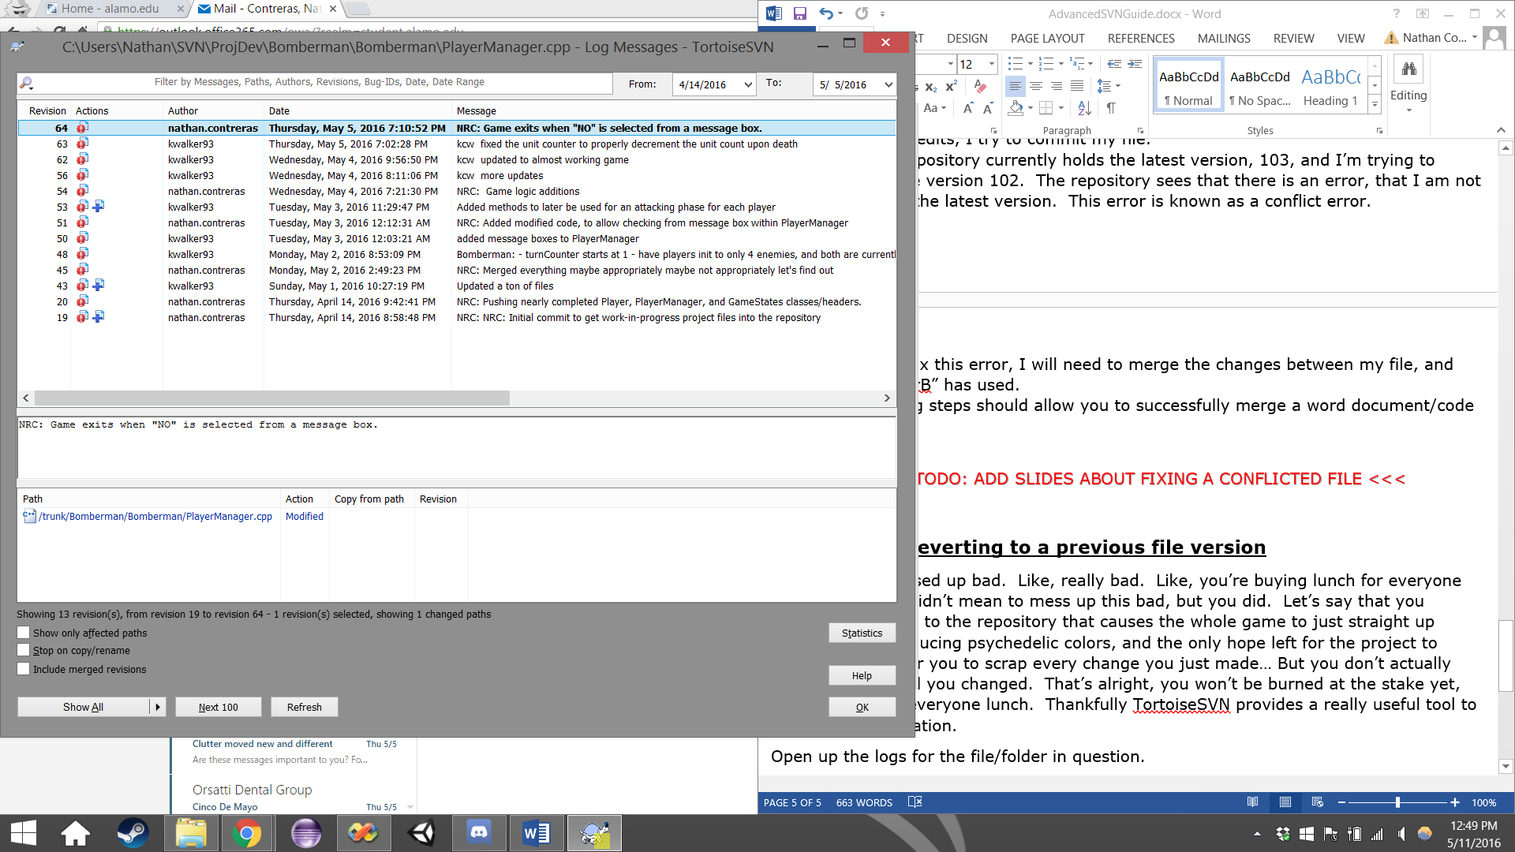

Let’s say I made a mistake, I pushed revision 64. I know the last time our game was working, kwalker93 had pushed version 63. I will want to keep track of this number. Click OK.

Right click the file/folder and select TortoiseSVN, and then select “Update to revision…”

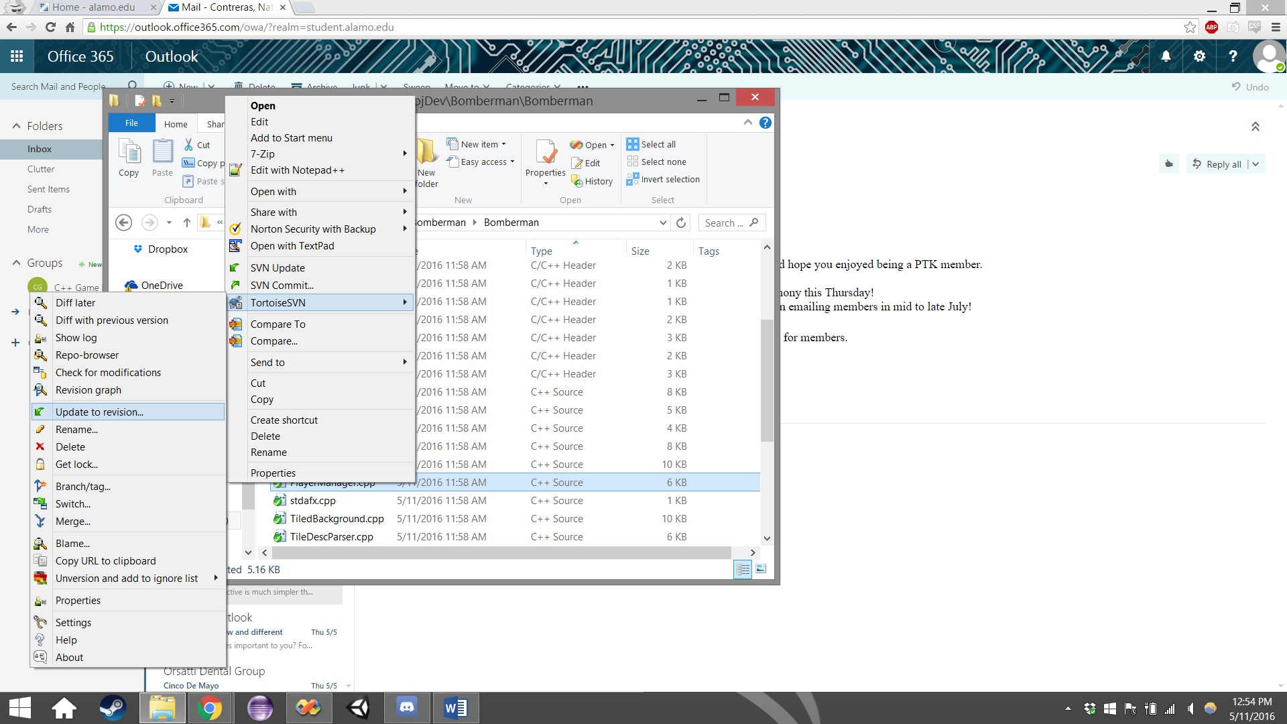

Click the radio-button labeled “Revision” and enter the desired revision number. Click OK.

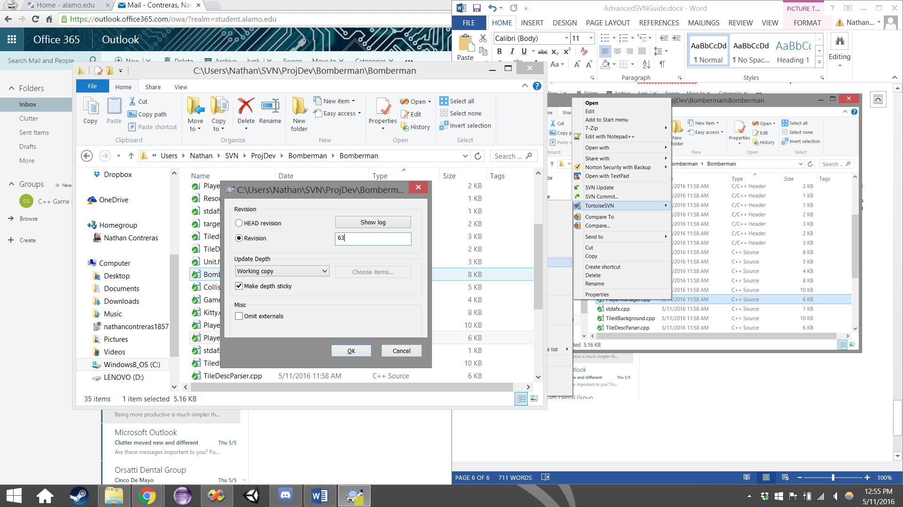

You will see the update screen pop up. Once you see “Completed” click OK.

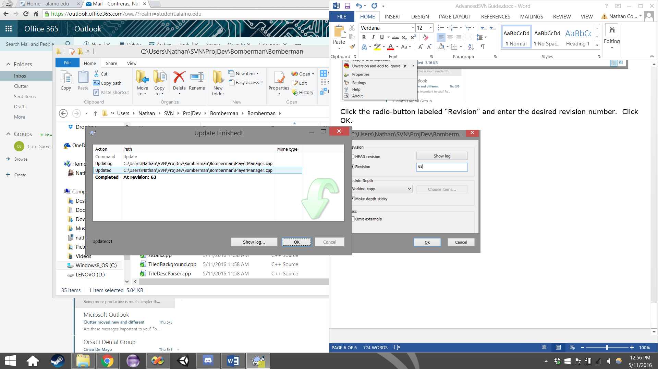

Your file should now be reverted to desired version you selected, congratulations!

**SECTION 5: Modifying your context menu**

Let’s say some buttons aren’t displaying on your context menu when you right click a file or folder. This is likely because you haven’t modified your context menu settings yet.

Go ahead and right click anywhere, preferably in white space. Select TortoiseSVN and select “Settings”.

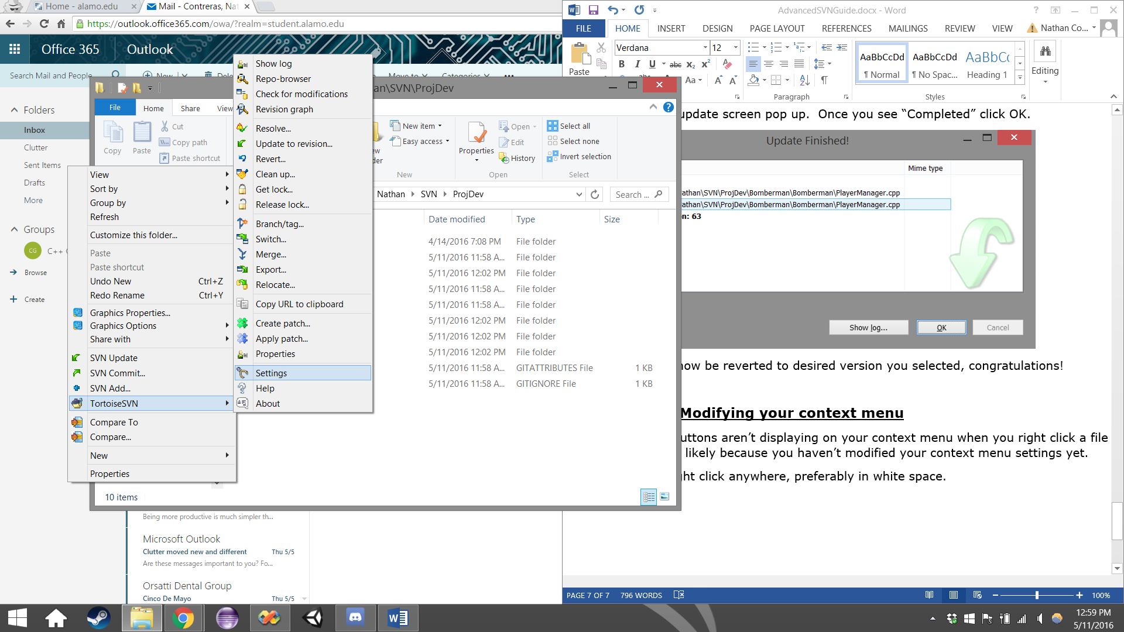

You will be presented with this screen

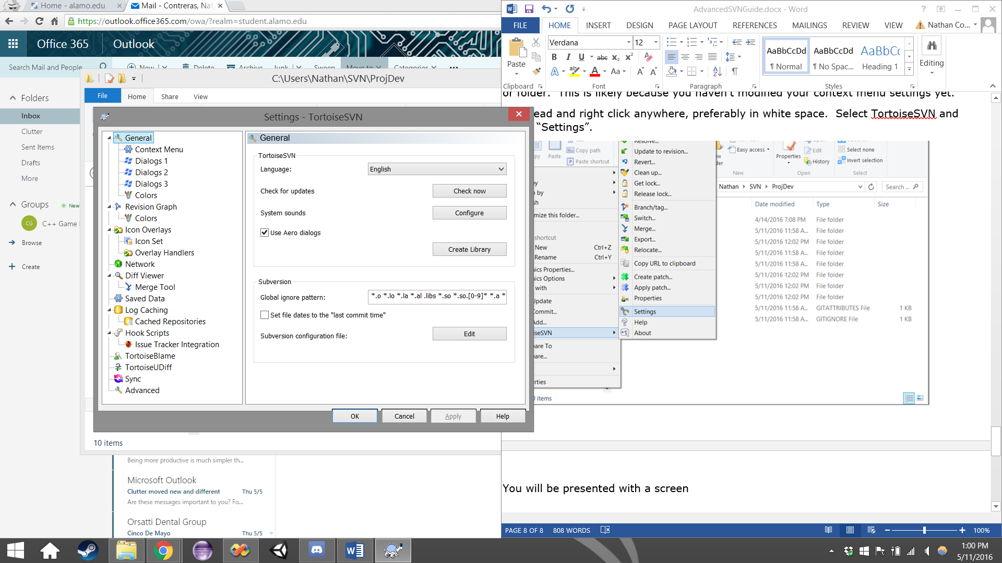

Go ahead and select “Context Menu” on the left bar, under “General”.

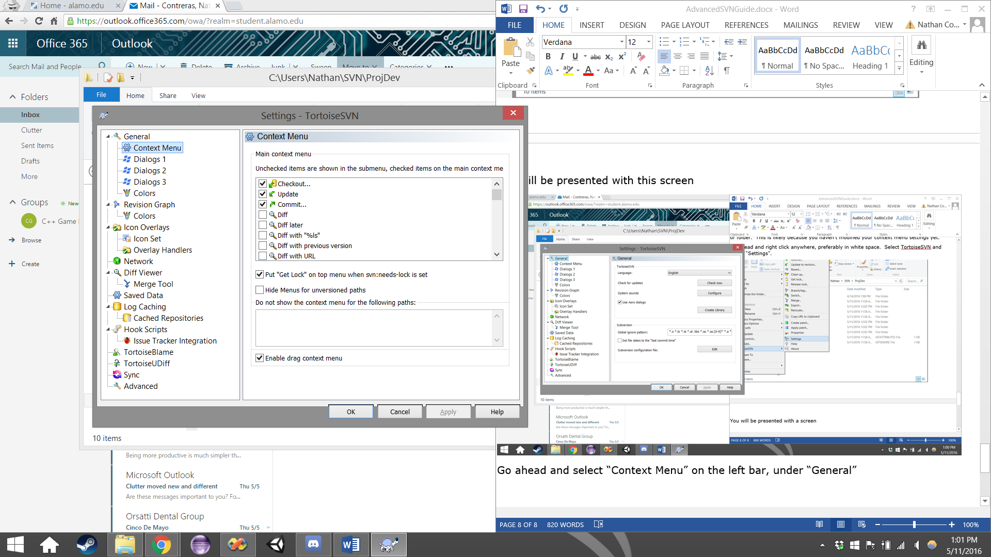

From here you can check and uncheck items that you wish to display on your context menu. The left menu represents what my context menu used to look like. The one on the right represents what my context menu looks like now, after modifying the context menu settings.

 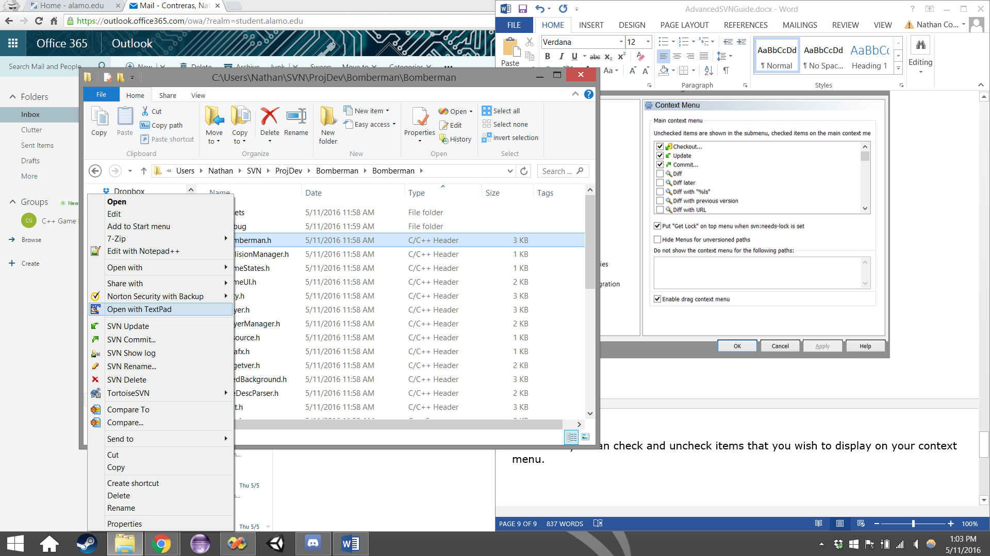

Easy as mashed potatoes right? Good. Moving on.

**SECTION 6: Renaming a versioned file.**

Let’s say you mistaking named your script “FluffyBunnyMacDougle.cs” instead of “DemonKingStrentzsch.cs”, we can’t just use the windows default “Rename” because that’ll not let the repository know we want to change our versioned file’s name, and the next time we update, it will just re-downloading the now “missing” file. (Notice, if you modified your context menu, the locations of buttons will not appear in their default locations.)

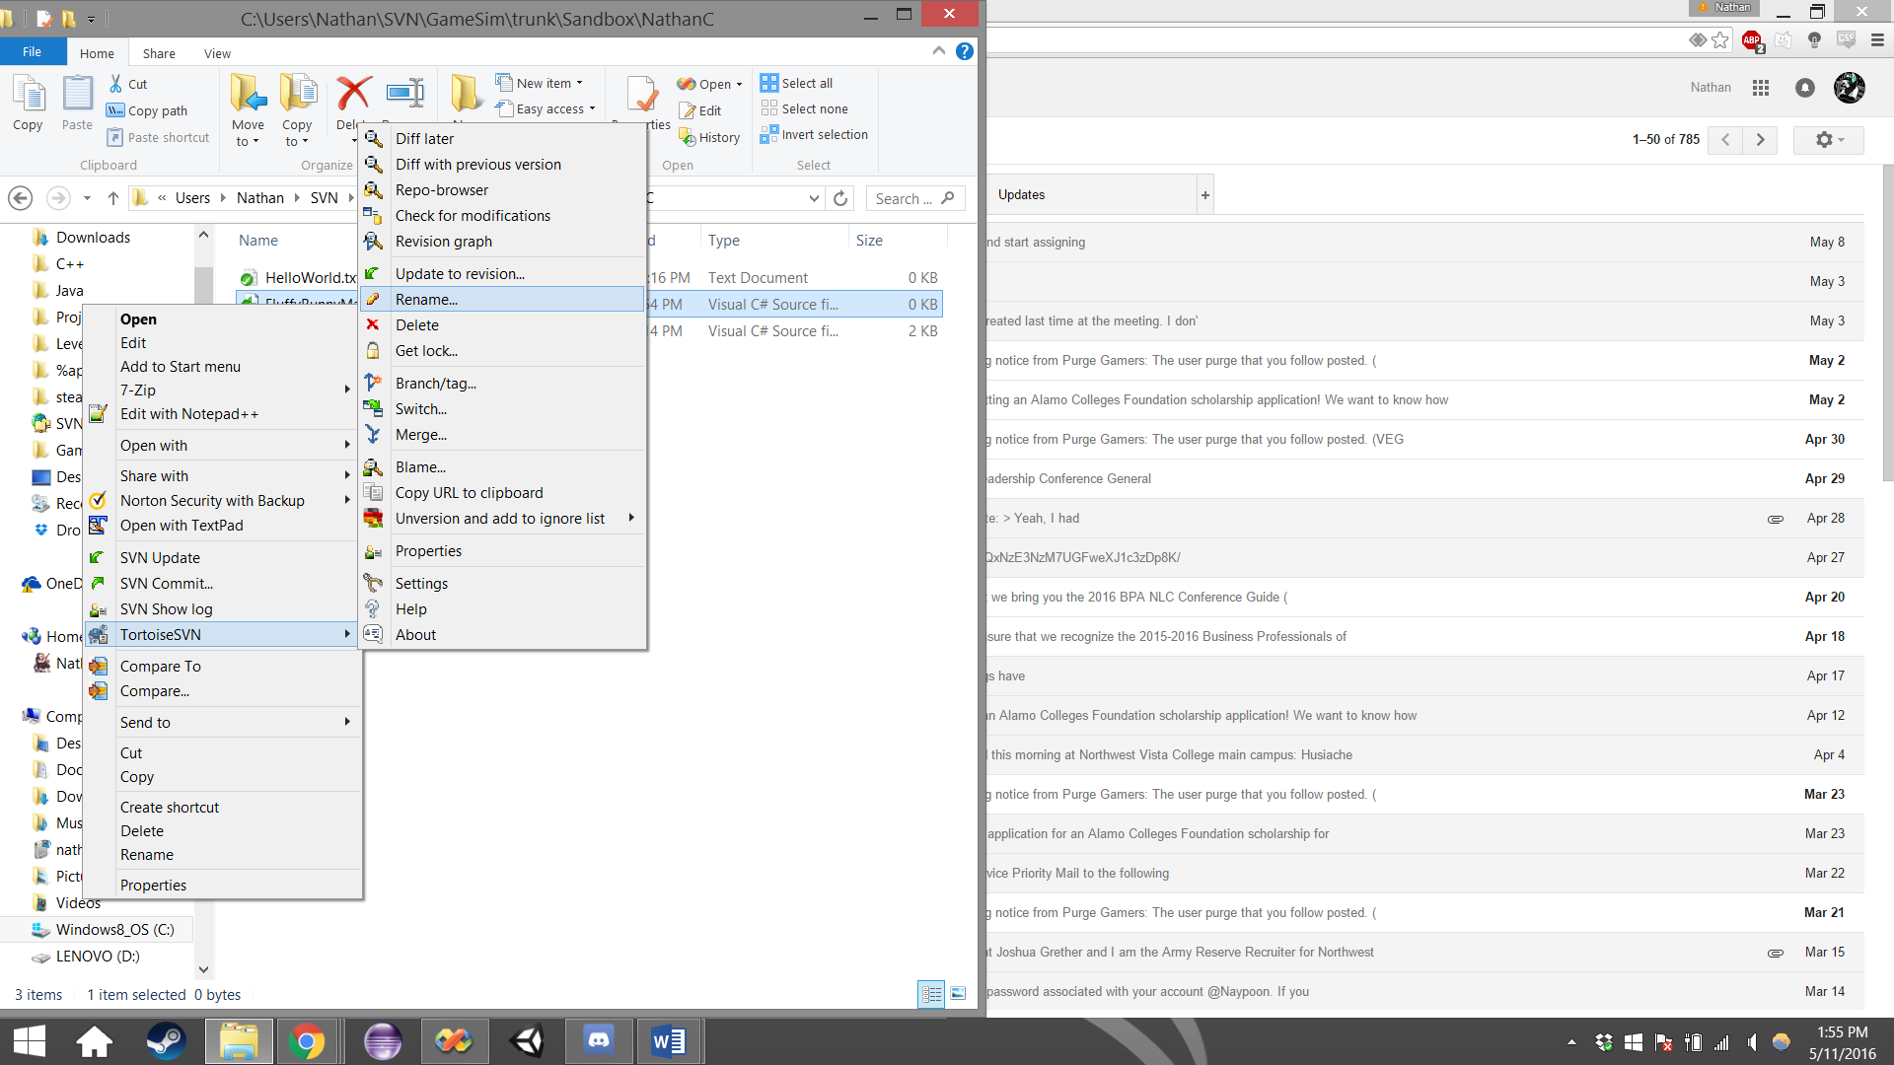

Now you will be presented with this screen, rename the file to your desired name, and then click OK.

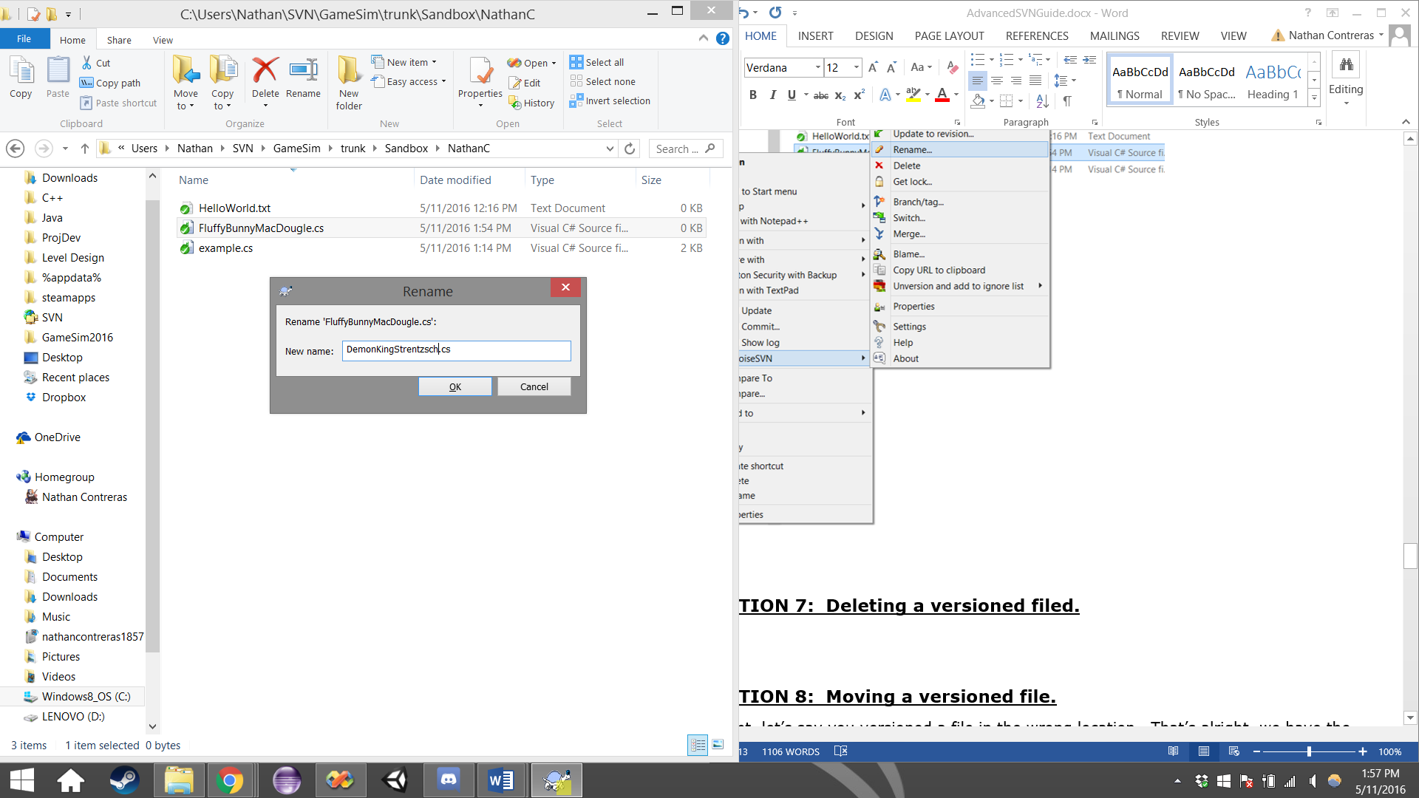

Notice below how the file has been renamed, but we don’t have a happy little green checkmark on our file? That’s because we haven’t finalized the changes yet, to do so we will commit. But we can’t just commit our newly name file, because it is not the only change to have been made here.

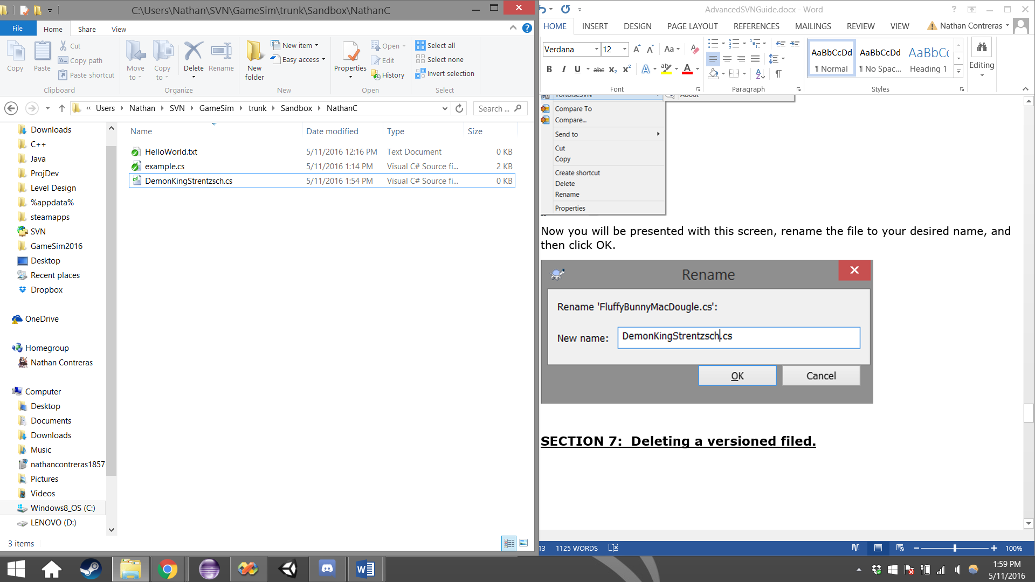

To commit this change successfully, we will need to move up one level to the parent folder.

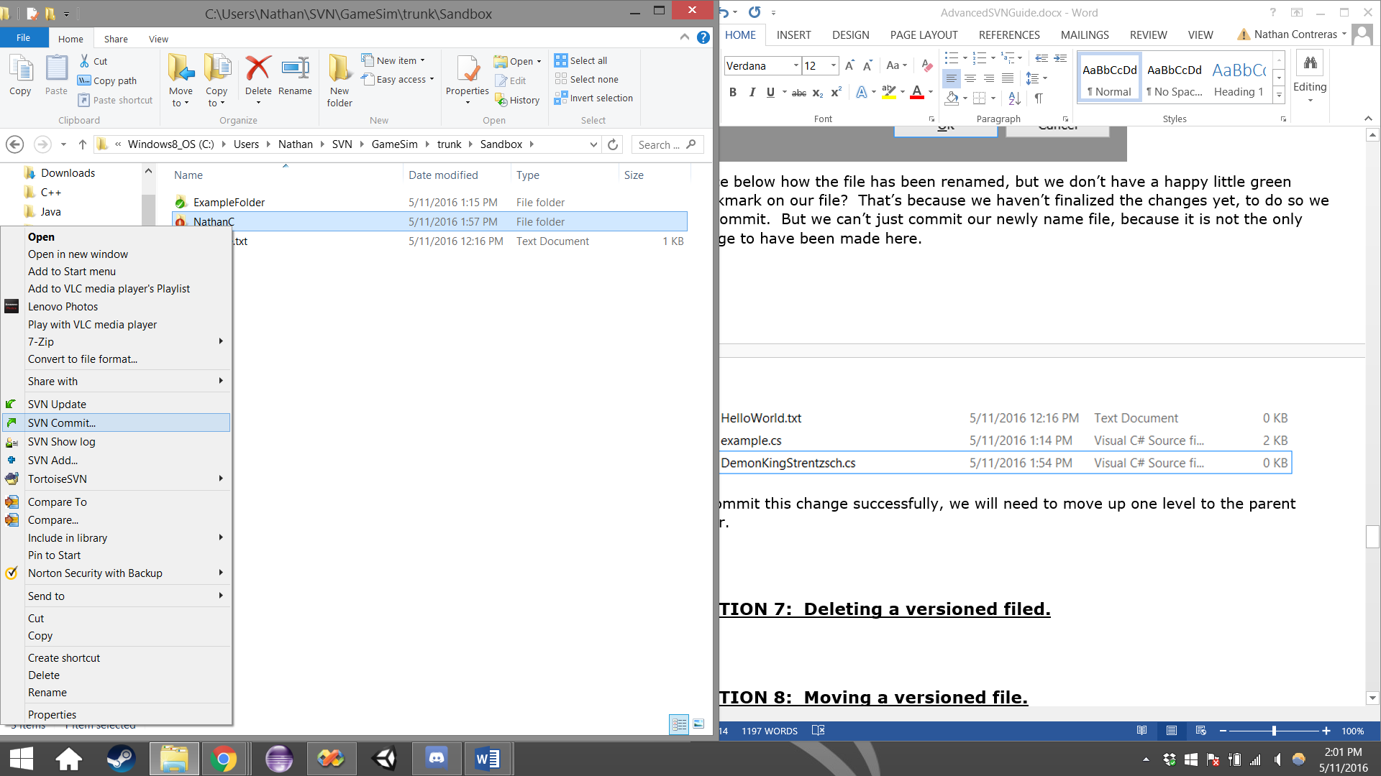

Now select the parent folder, and click SVN Update, to ensure the changes have been made on your local file system. Afterwards, click commit. Below the text field, you can see the technical operations that have occurred here. Click OK when you have entered a comment into the text field.

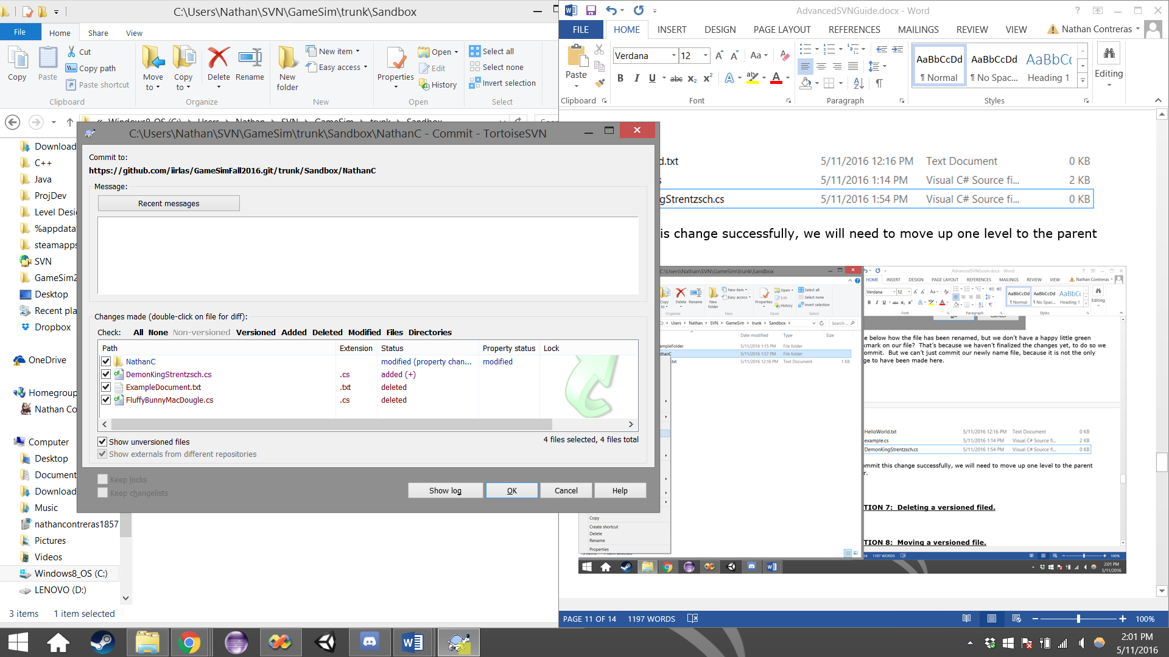

Congratulations, you’ve successfully renamed the file using Tortoise!

**SECTION 7: Deleting a versioned filed.**

Let’s say you added a file you didn’t actually need to add to the repository. The solution here would be to delete the file. However, we can’t just delete the file using the built in windows delete feature, we have to use the delete function provided by TortoiseSVN.

Right click the file/folder and select TortoiseSVN, then select “Delete”.

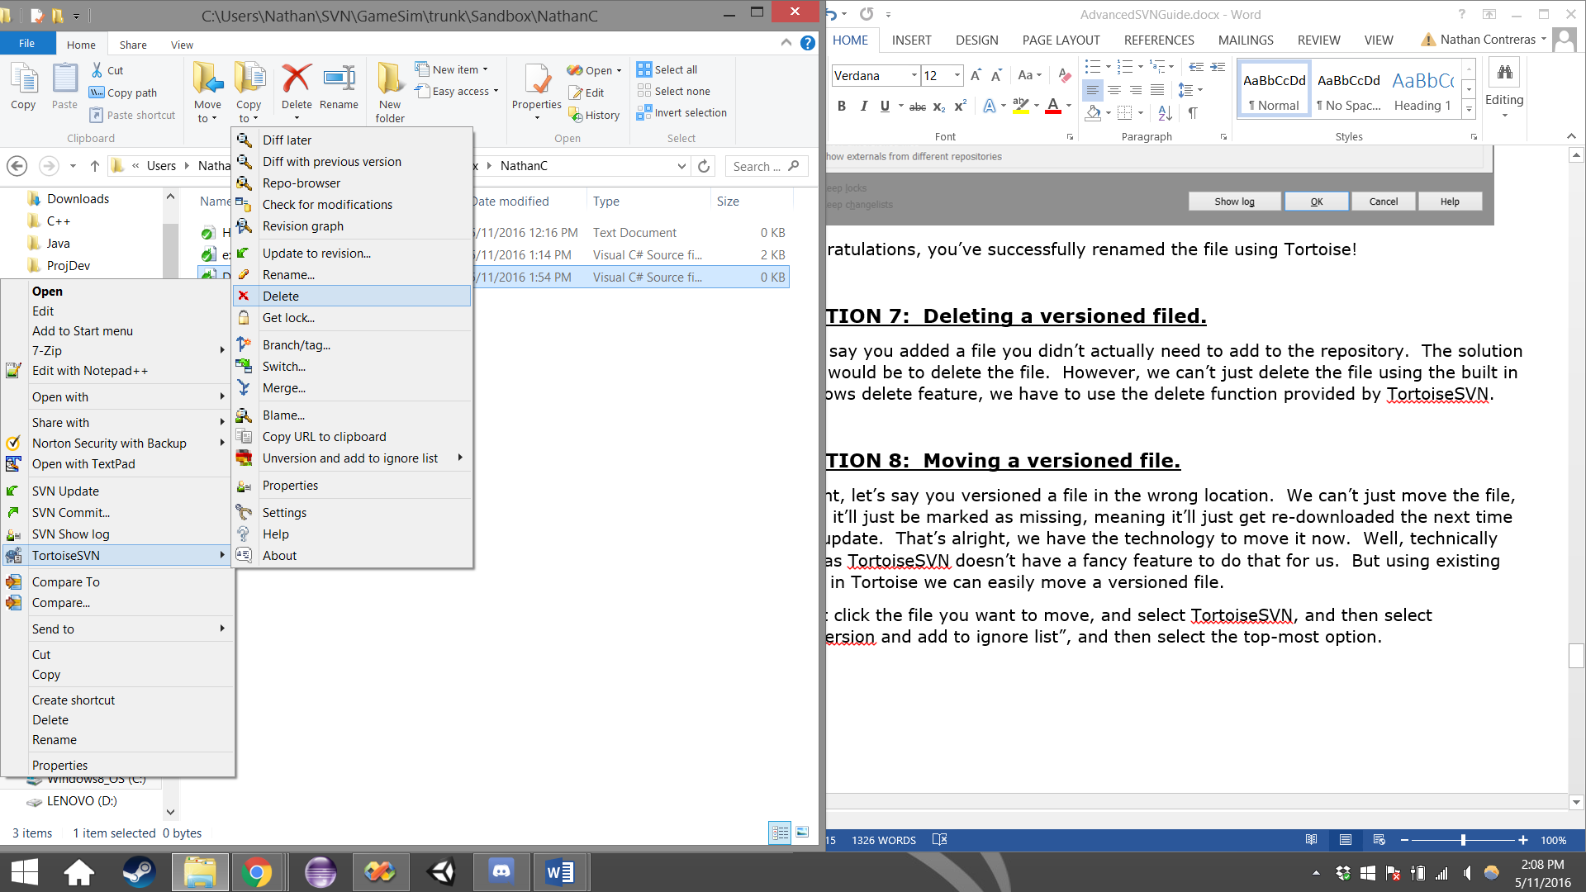

The file has now be marked as deleted, and will be removed locally from your system.



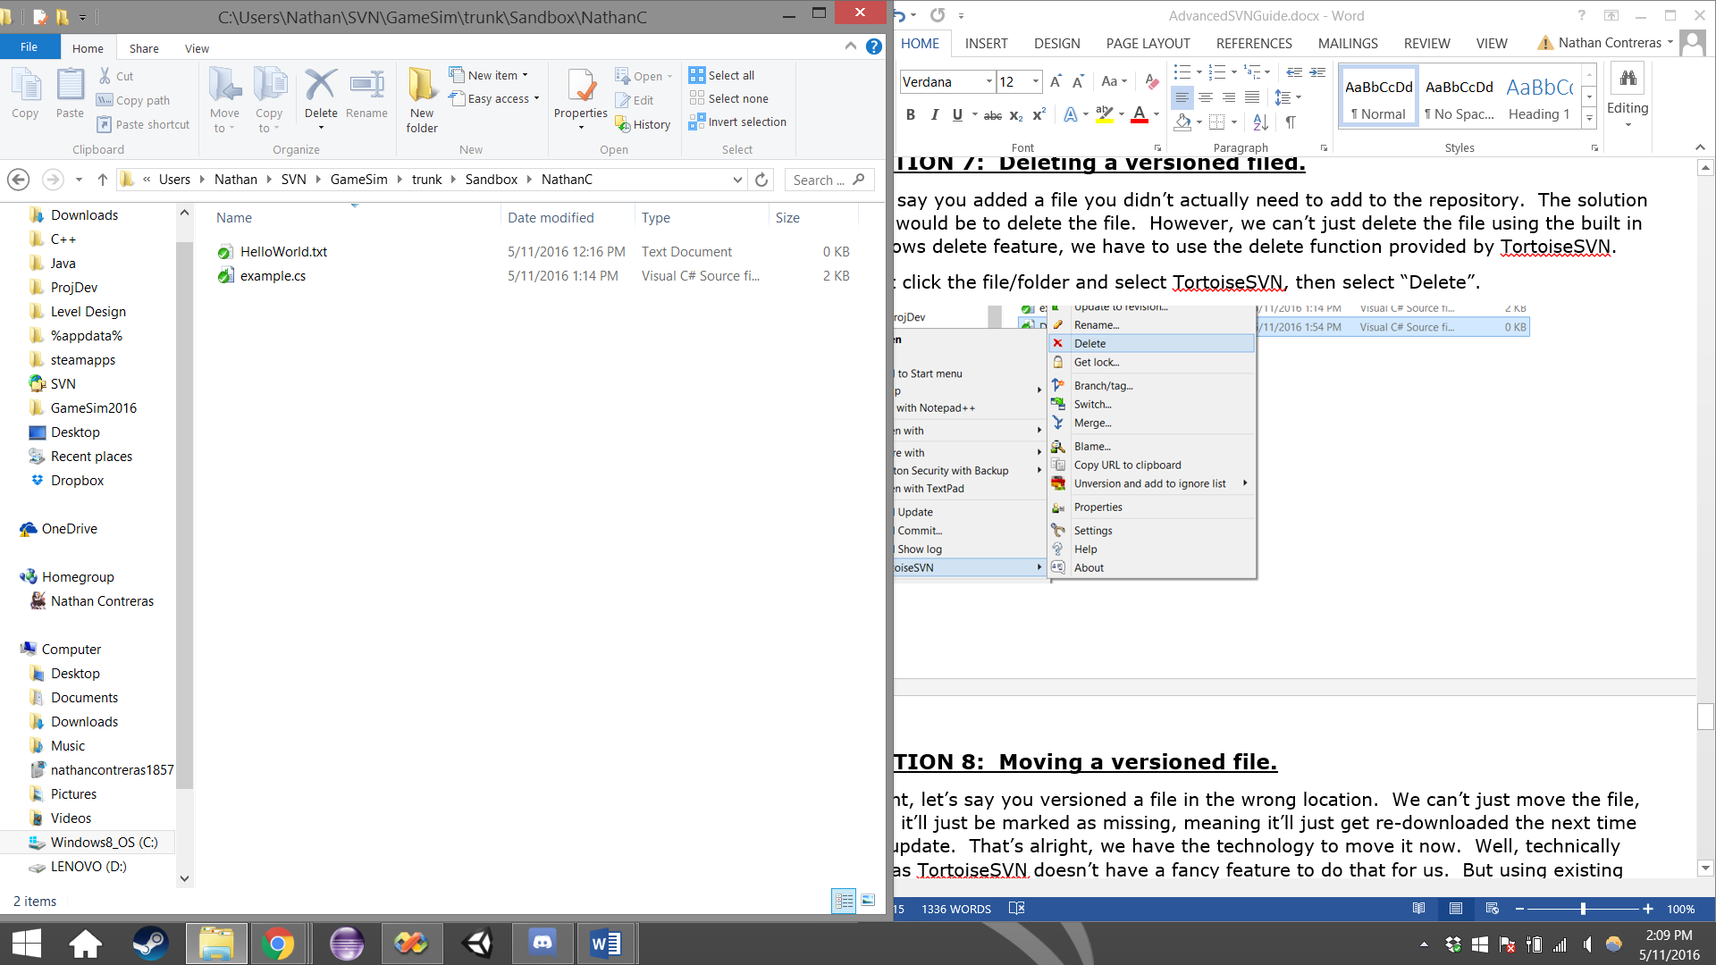

Next, in order to finalize the transaction, we need to commit the parent folder. Go up a level to the parent folder, and right click it. Then select SVN Commit.

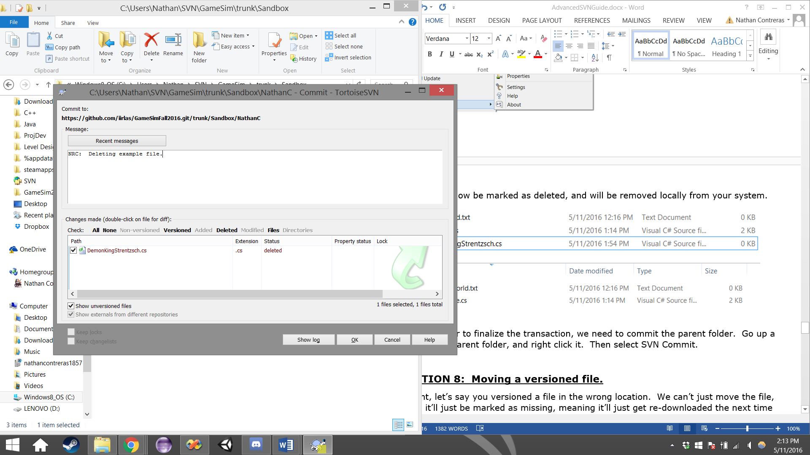

Click OK, you will have successfully deleted a versioned file from the repository. Congratulations.

**SECTION 8: Moving a versioned file.**

Alright, let’s say you versioned a file in the wrong location. We can’t just move the file, since it’ll just be marked as missing, meaning it’ll just get re-downloaded the next time you update. That’s alright, we have the technology to move it now. Well, technically not, as TortoiseSVN doesn’t have a fancy feature to do that for us. But using existing tools in Tortoise we can easily move a versioned file.

Right click the file you want to move, and select TortoiseSVN, and then select “Unversion and add to ignore list”, and then select the top-most option.

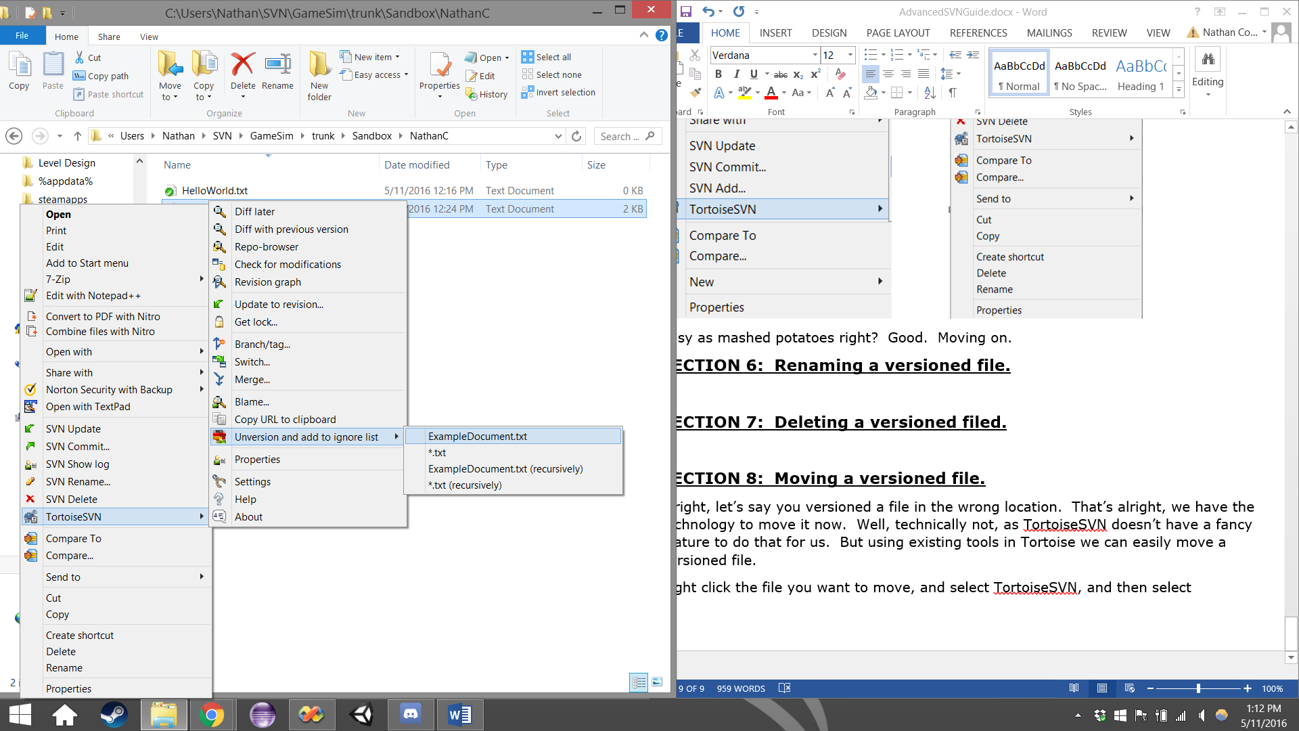

You will see this pop-up box. Click OK.

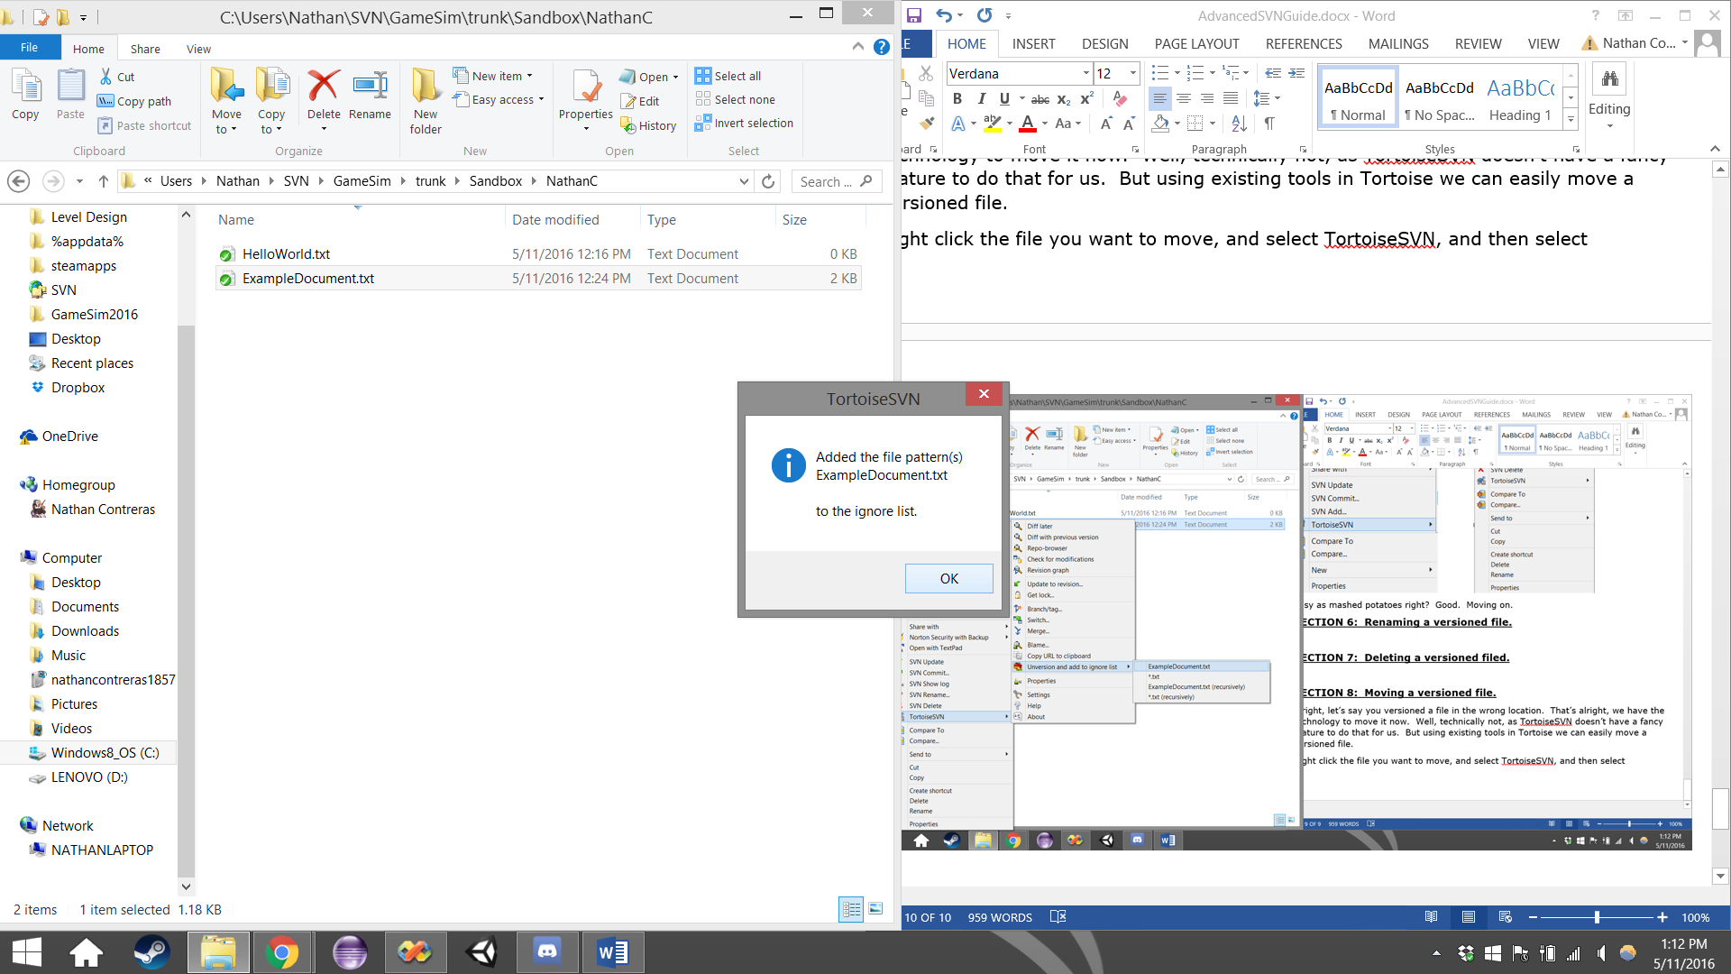

Now the file will be unversioned, and you will not see a green check-mark.

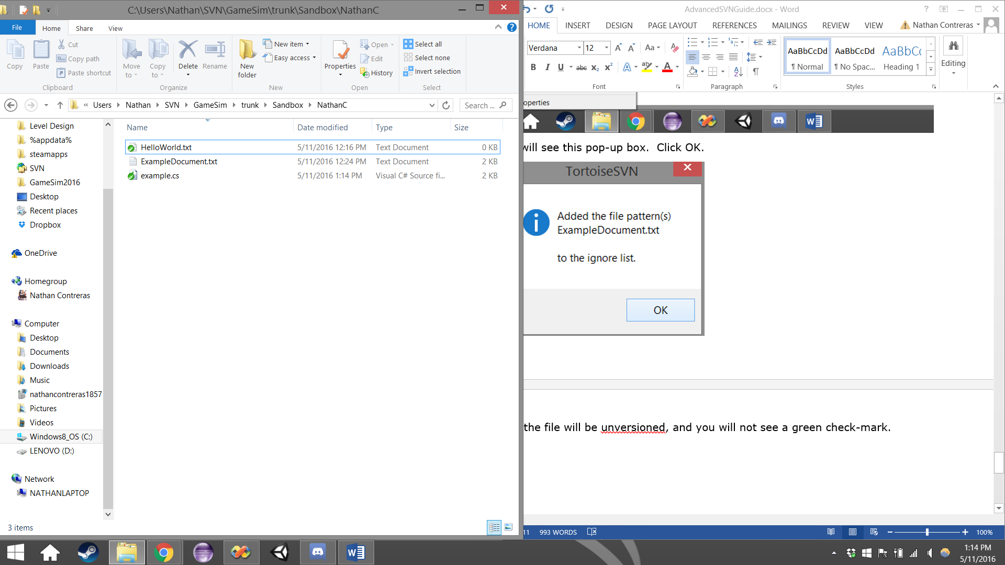

Now you can move this file to a new folder. I moved this file from my folder in Sandbox to the ExampleFolder in Sandbox.

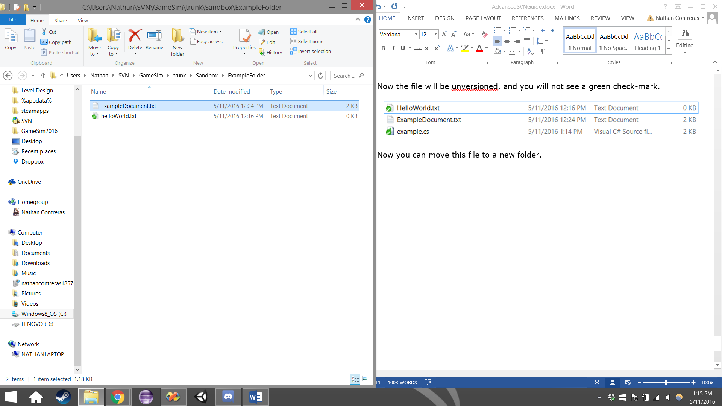

Now you will just need to add, and commit the file to the repository, and you’ll be done.

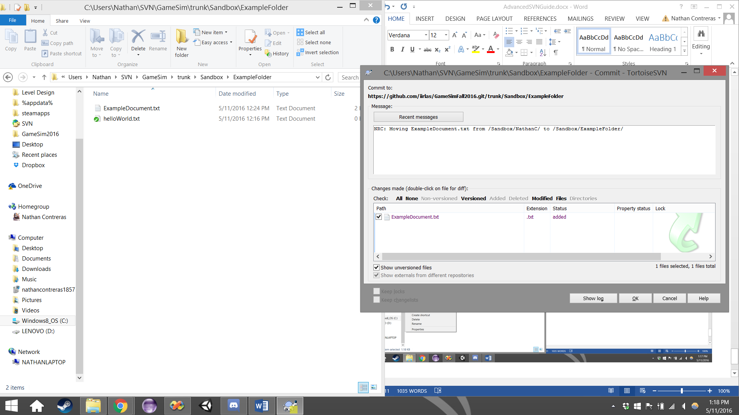

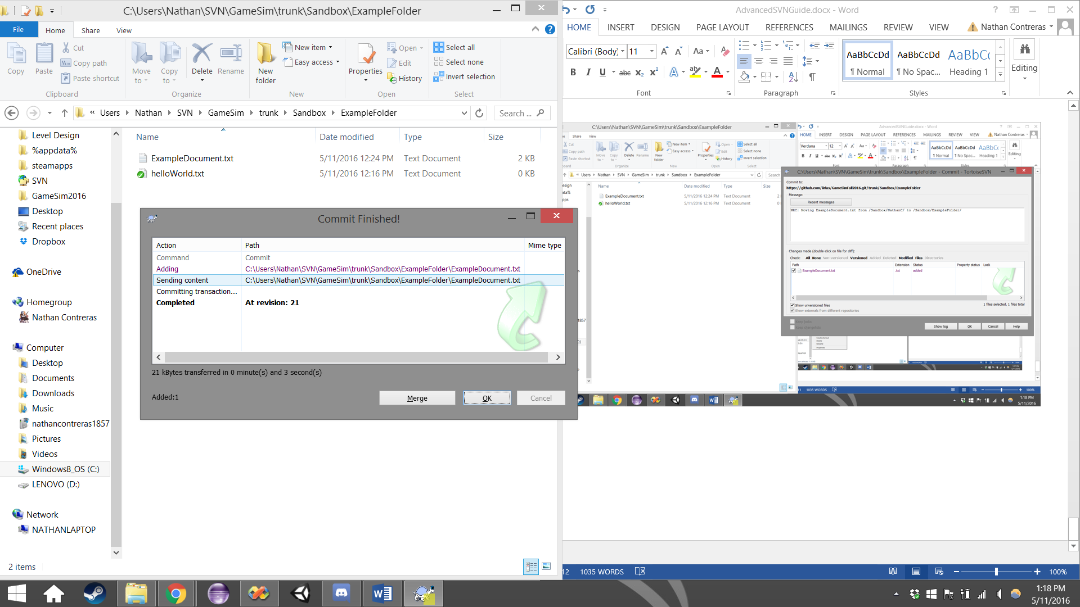

Congratulations, you’ve successfully moved a version file!